HISTORY OF THE

KULALUK LEASE
by
Krimhilde Henderson
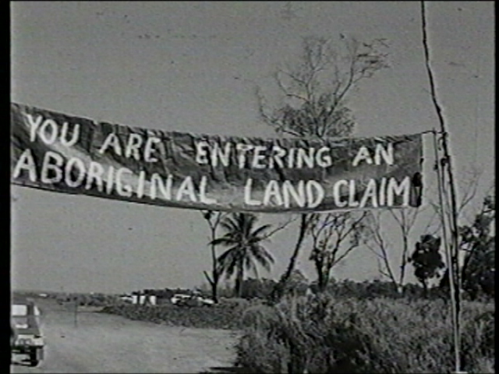

Above: Enrance to the Kulaluk claim on Ostermann Street, Coconut Grove, 2 June 1973.

Aboriginal Sacred Sites Authority
Darwin
1984
Reprinted in 2009 by W B Day

